SOKOBAN SOLVING with SEARCH ALGORITHMS
Abdurrahim Gün
Department of Artificial Engineering
a.gun@etu.edu.tr

Abstract - Sokoban is a puzzle game where a warehouse operator must push boxes to designated target points. The aim of this project is to apply and evaluate various search algorithms for solving the Sokoban game. The study comparatively examines classical and modern search methods such as breadth-first search, depth-first search, A*, and iterative deepening A*. The effectiveness of each method has been assessed in terms of solution time, memory usage, and the optimality of the found solution. Additionally, the unique challenges of Sokoban, especially the potential for boxes to block each other and the complexity of the sequence in reaching targets, have been analyzed in detail regarding their impact on the performance of search algorithms. The results obtained in the project suggest the most suitable search strategies for specific types of puzzles and highlight the potential of search algorithms in solving NP-hard problems like Sokoban.

Keywords— Sokoban, Artificial Intelligence, Search Algorithms, A*, BFS, IDA*.

INTRODUCTION
Building on the initial overview, the expanded introduction delves deeper into the intricacies of the Sokoban game itself, setting a comprehensive backdrop for the project's goals and methodologies. Sokoban, a puzzle game originating from Japan in 1982, challenges players to push boxes to designated storage locations within a confined space, usually a warehouse. The player controls a warehouse worker (or "Sokoban" in Japanese), navigating through a grid-like level filled with obstacles. The game's seemingly simple premise belies the complexity of its puzzles, which require strategic planning and foresight to solve. Each move must be meticulously calculated, as incorrect maneuvers can lead to unresolvable situations, necessitating a level restart.

The computational rendition of Sokoban offers a rich canvas for artificial intelligence (AI) research, particularly in the realm of problem-solving and optimization. The game's complexity, characterized by its NP-hard status, makes it an ideal candidate for exploring advanced AI techniques. In this project, the implementation of Sokoban not only serves as a testbed for AI algorithms but also provides a platform for investigating the interaction between AI and human cognition in problem-solving contexts. This aspect is particularly relevant for developers and researchers aiming to design AI systems that complement human intelligence, rather than operate in isolation from it.

By focusing on AI-driven solutions for Sokoban, the project aims to harness the power of algorithms to navigate through the game's intricate puzzles efficiently. The selection of algorithms will span from traditional search methods, such as depth-first and breadth-first searches, to more sophisticated techniques, including heuristic-based searches and machine learning models. This broad spectrum of methodologies enables a comprehensive analysis of algorithmic performance across various metrics, including efficiency, scalability, and adaptability to increasing levels of complexity.

Moreover, the project will explore the potential of AI in enhancing the game design process itself. By evaluating the AI's ability to solve Sokoban puzzles, insights can be gained into the design of puzzles that are challenging yet solvable, striking a balance between difficulty and enjoyment. This aspect of the project underscores the synergy between AI and game design, where AI not only solves puzzles but also informs the creation of engaging and intellectually stimulating games.

In sum, this introduction frames the project as a multifaceted investigation into the application of AI in solving and designing Sokoban games. It highlights the game's significance as a platform for AI research, emphasizing the project's potential contributions to the fields of artificial intelligence, computer science, and game design. Through a meticulous examination of AI algorithms' capabilities in tackling Sokoban's challenges, the project aims to advance the understanding of AI's role in problem-solving and game development. This endeavor is positioned as a valuable addition to the ongoing discourse on the power of AI to transform game design and enhance our approach to complex problem-solving scenarios.

II. REVIEW OF ARTIFICIAL INTELLIGENCE APPROACHES
In the course of our research, it has been observed that for puzzle games like Sokoban, a "Lower Bound Estimation" must be made for each node in the search tree (depending on the methods used, not every node may require this) to assess "How far is the solution?" However, calculating this value for every node significantly impacts the designed algorithm's performance. One solution to this issue has been the utilization of uninformed search methods that do not rely on lower bound information. Among these methods, Breadth First Search (BFS), which guarantees a solution, and Iterative Deepening Depth First Search (IDDFS), which benefits from DFS’s memory complexity advantages while preventing the infinite loops associated with DFS, stand out. Nevertheless, due to the high time complexity of these methods, they have been observed to be used in conjunction with additional techniques (such as PI-corral Pruning and Van Lishout) to improve performance.

To briefly explain the search algorithms mentioned:

Breadth-First Search (BFS)
BFS explores the search tree level by level, starting from the root node and expanding all its neighbors before moving to the nodes at the next depth level. This method ensures that if a solution exists, it will be found at the shallowest level, guaranteeing an optimal solution in terms of the number of moves. However, BFS can consume significant memory resources as it needs to store all nodes at the current depth level before moving to the next.

Depth First Search (DFS) and Iterative Deepening Depth First Search (IDDFS)
DFS explores as far as possible along each branch before backtracking, which can lead to lower memory consumption but does not guarantee finding the shortest path to a solution. To counteract the limitations of DFS, particularly its propensity for getting trapped in loops, IDDFS combines the depth-first search's space efficiency with the level-by-level exploration characteristic of BFS. It incrementally deepens the depth at which it searches, thereby preventing the infinite loop issue of DFS while still utilizing less memory than BFS.

Informed Search Methods and IDA*
Informed search methods, employing heuristics to guide the search process towards the goal more efficiently, were also considered. The IDA* algorithm emerged as a particularly effective method. IDA* iteratively deepens the search depth, guided by a cost function that combines the actual cost to reach a node (g(n)) and the estimated cost from that node to the goal (h(n)), ensuring an optimal solution under the condition that the heuristic is admissible and consistent. This approach significantly reduces the time complexity by avoiding the exhaustive exploration of non-promising paths.

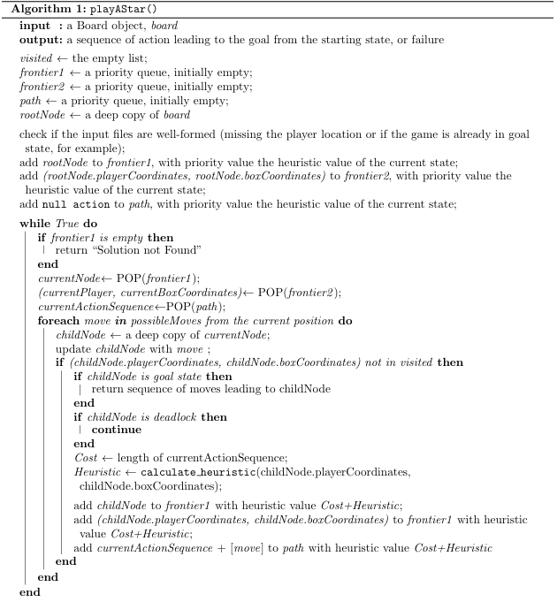

Search methods that utilize information about each box's distance to the target, the warehouse operator's distance to each box, and which moves would result in irreversible situations preventing a solution, will also solve this problem. However, as mentioned above, finding a heuristic value for every node significantly increases the time complexity. Therefore, the Iterative Deepening A* (IDA*) algorithm has been chosen. IDA* works by repeatedly performing a depth-limited search, increasing the search depth with each iteration. This depth limit is based on a cost function determined with the help of a heuristic function (usually f(n) = g(n) + h(n), where g(n) is the cost from the start node to node n, and h(n) is the estimated cost from n to the goal). IDA* expands nodes up to the limit set by the cost function in each iteration. If the solution is not found, the limit is set to the minimum cost function value encountered in the last search, and the search is repeated. IDA* is advantageous over the classic A* algorithm in terms of memory, speed, simplicity, and guarantees an optimal solution under the condition that the heuristic function is admissible and consistent. Besides these advantages of the IDA* algorithm, the correct construction of the game tree is also essential, following the steps below:

- Push Level Search: In Sokoban, the pusher can move freely on the board, but only moves that change the positions of boxes matter. This approach considers high-level moves where boxes are pushed, rather than individual moves, and searches are conducted on these moves. This method can increase the branching factor in situations where the player can reach many boxes from different directions, but it significantly reduces the search depth and minimizes the frequency of loop formations, thereby reducing the additional burden of loop avoidance.

- Deadlock Detector: In our algorithm's description, we discuss an essential operation that evaluates if a game state has reached a deadlock, meaning it's impossible to relocate all boxes to designated storage spots. Identifying such states is crucial because once a game enters a deadlock, continuing the exploration of subsequent states becomes futile, rendering the puzzle unsolvable from that juncture. To address this, our solution includes specific functions designed to detect deadlocks, effectively narrowing the search tree by eliminating unproductive paths. The primary deadlock scenario identified is the "corner deadlock," where a box is trapped by walls on two adjoining sides, rendering it immovable. Our detection strategy for this scenario is straightforward: we examine each box to see if it is adjacent to walls in two perpendicular directions. Another significant scenario is the "pre-corner deadlock," which accounts for boxes that, while not immediately trapped, are on an inevitable path to becoming cornered. This occurs when a box is against a wall and can only move along that wall, with no storage locations along its path or when a storage spot is present but blocked by a wall. Initially, our detection mechanism was optimistic about such scenarios, but we've since refined it to recognize situations where a storage location's accessibility is obstructed by a wall as deadlocks too. We also identify a scenario we've termed "square deadlock," where a group of more than four boxes forms a rigid rectangle, making it impossible to move any of the boxes within this formation. This detection involves checking for the presence of adjacent boxes to a given box's right, lower right, and directly below.

- Tunnel Macros: Tunnels are sections of the level where only one move can be made. If more than one box is in a tunnel, a deadlock occurs. During the search, to prevent unnecessary searches in tunnels, when a box enters a tunnel, all moves are combined and processed as a single move until the box is removed.

- Transposition Tables: These tables prevent revisiting the same states (or game board configurations) by recording visited states during the search, thereby avoiding cycles and reducing the branching factor.

- Move Ordering: The children of a node are ordered based on their likelihood of leading to a solution. Moves that maintain momentum by pushing the same box as in the previous move are considered first, followed by moves ordered based on the box's distance to the target storage area, and finally, less optimal moves ordered based on distance to the target are tested.

- Deadlock Tables: These tables utilize a pattern database containing all possible deadlock configurations on the game board. The tables are created offline with all possible combinations of walls, boxes, and empty positions for a specific area.

Considering the adaptation of the problem as a Constraint Satisfaction Problem (CSP), we initially intended to follow the outlined steps. However, due to challenges encountered in adapting the problem into a CSP framework, this approach was abandoned. Instead, the project focused on running the A* and IDA* algorithms with different heuristic functions. This shift allowed for a more direct and effective application of informed search strategies, significantly enhancing the algorithms' performance in solving Sokoban puzzles. Throughout the project, special attention was given to the design of the game tree structure using the IDA* algorithm as detailed above. Additionally, performance comparisons were conducted between an uninformed search method and the informed search methods, highlighting the superior efficiency and effectiveness of the latter when equipped with the right heuristic information.

III. METHODOLOGY
The computer simulation of the Sokoban game provides a platform focused on enhancing strategic thinking and problem-solving skills. This simulation initiates by offering the user two fundamental modes: the first is the option to play the game directly, and the second is to observe the automatic resolution of the game through various search algorithms. The choice of mode determines how the user interacts with the simulation. If the observation mode is selected, the user has the opportunity to choose from different search algorithms, such as Breadth-First Search (BFS) or A*, among others. These algorithms determine the most efficient way to move the boxes to their designated target points by automatically solving the game.

Each level selected by the user defines a starting condition and objectives for the Sokoban game, allowing the user to customize their gameplay experience. During gameplay, the user controls the warehouse worker using arrow keys, directing the boxes towards predetermined targets by pushing them. In observation mode, however, the chosen search algorithm calculates the most appropriate moves on the game board, presenting the automatic solution of the game. This process is visually tracked through the simulation's graphical interface.

In conclusion, the Sokoban game simulation emerges as an educational tool aimed at fostering algorithmic thinking and problem-solving abilities. By providing users with the opportunity to engage directly in gameplay or observe the solution processes of algorithms, this simulation offers a practical experience in the fields of computer science and artificial intelligence. Highlighting the efficiency of search algorithms and their significance in applied computer sciences, this platform contributes to the enhancement of users' knowledge and skills in these areas.

IV. RESULTS and CONCLUSION
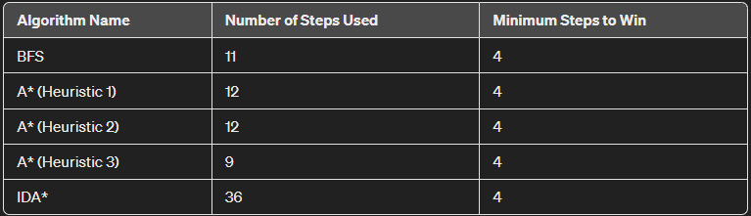
Figure 1

The performance of the algorithms on a fairly simple Sokoban map is shown in figure 1.

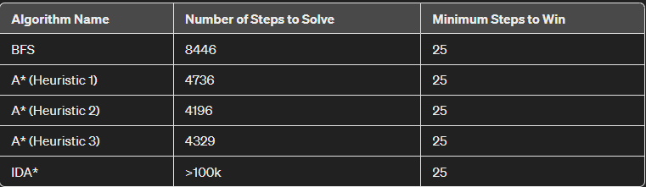
Figure 2

For a more difficult example, the result is shown in Figure 2.
The A* algorithm is often more successful in solving a variety of problems compared to IDA* and BFS (Breadth-First Search) algorithms. This success is primarily due to its efficiency, flexibility, and optimization capabilities. This essay will detail these three significant advantages of the A* algorithm, explaining its superiority over other algorithms.
The A* algorithm is often more successful in solving a variety of problems compared to IDA* and BFS (Breadth-First Search) algorithms. This success is primarily due to its efficiency, flexibility, and optimization capabilities. This essay will detail these three significant advantages of the A* algorithm, explaining its superiority over other algorithms.

The flexibility of the A* algorithm comes from its use of heuristic functions that can be adapted to different problems and conditions. These heuristics, which utilize problem-specific information, can significantly enhance the performance of the algorithm. For instance, when finding the shortest path on a map, "Straight line distance" or "Manhattan distance" heuristics can be employed. Although IDA* also uses flexible heuristics, it does not offer as wide a variety as A*. BFS, on the other hand, lacks this kind of flexibility since it explores all nodes equally without making any cost estimations.

A* algorithm allows for optimization in finding the best path. With the correct choice of heuristic, A* guarantees to find an optimal path. This is a major advantage in complex situations with many alternatives. IDA* can also provide optimal results but is not as efficient as A*; because it expands the search space with each iteration, increasing time and memory usage. BFS can theoretically deliver correct results in finding the shortest path; however, it is limited in practice due to its significant memory requirements and slow operation speed.

In conclusion, the A* algorithm demonstrates superior performance in solving various problems due to its efficiency, flexibility, and optimization capabilities compared to IDA* and BFS. These features make A* the ideal choice for wide search areas, different types of problems, and situations where an optimal solution is required. Therefore, the A* algorithm is frequently preferred in modern computer science and artificial intelligence applications.

IV. GENERAL EVALUATION
In this report, we conducted a comparative analysis of the A*, IDA*, and BFS algorithms. We detailed how the A* algorithm surpasses the other two in terms of efficiency, flexibility, and optimization capabilities. However, it should be noted that theoretically, IDA* may have advantages over A* in certain scenarios. This section summarizes our findings and explains why, despite IDA*'s theoretical advantages, A* proves to be superior in practical applications.

The A* algorithm finds the least costly path to the goal by considering both the actual cost and the estimated cost during the search. This approach enables the algorithm to quickly and effectively solve problems across broad search spaces and various problem types. In contrast, the IDA* algorithm is based on depth-limited search, iteratively deepening the search when a certain depth limit is reached. Theoretically, this method could be more efficient than A*, especially in terms of memory usage, in large search spaces.

However, in practice, the flexibility and optimization capabilities of the A* algorithm often make it superior to IDA*. With A*, the search space can be effectively narrowed down through the use of problem-specific heuristics, avoiding unnecessary computations. The theoretical advantages of IDA* often remain limited when faced with the diversity and complexity encountered in real-world problems. Particularly, the selection and implementation of heuristic functions play a critical role in the ability of the A* algorithm to adapt to different problems and situations.

Moreover, the optimization capability of A* guarantees the finding of the optimal path, whereas IDA* may sometimes need to perform repetitive searches, requiring more time and memory. Additionally, the A* algorithm is widely accepted and preferred in real-time applications and complex systems, especially in areas such as pathfinding and game theory.

In conclusion, although IDA* possesses certain theoretical advantages, the A* algorithm remains a more successful and preferred method for solving real-world problems due to its practical flexibility, broad applicability, and optimization capability. This analysis clearly demonstrates why the A* algorithm is frequently chosen in modern computer science and artificial intelligence applications, underscoring its significance and effectiveness.

REFERENCES
- [1] Virkkala, Timo. Solving sokoban. Diss. Ph. D. dissertation, Masters thesis, University Of Helsinki, 2011.
- [2] Crippa, Mattia, Pier Luca Lanzi, and Fabio Marocchi. "An analysis of single-player Monte Carlo tree search performance in sokoban." Expert Systems with Applications 192 (2022): 116224.
- [3] Rendl, Andrea, et al. "Common Subexpressions in Constraint Models of Planning Problems." SARA. 2009.

